Graph search

The way graph search usually works is with a cursor moving from vertex to vertex until it has completed a complete rotation among the “findable objects”.
If n is the number of vertices and m is the number of edges, the optimal running time is O(n+m).

Theorem: If at a given step i, v node has been explored <=> there is a path from node s0 to v.

Breadth First Search
We start at zero, then next step we go to all the connected vertices to that one.
To do that, we are going to add a queue component to the code.
Breadth-First search has an aditionnal property: computing shortest path research

Undirected Connectivity
A connected component, or region, is a group of connected vertices. Using BFS, we want to compute all connected components, to check if there are unconnected nodes or interpret the graph.

Depth-First Search
Instead of exploring all the neighbors of a node at the same time, we make a straight line until we can't find any more edge or until we stumble upon an already visited node. If we stumble upon an already visited node and there are no unvisited edges left, we backtrack immediately. Running time is O(n+m)

Topological sort
Topological ordering of a directed graph is an ordering of the vertices so that all the directed edges go “forward” in the ordering according to a certain encoding of the vertices. This encoding is arbitrary to an extent, and so in the following example, w and v can be 2 and 3 each.
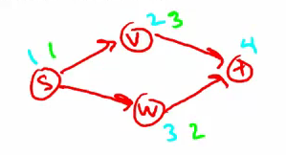
In both cases, the edge starting in w goes towards a subsequent node in the topological order.
This is used when you want to sequence a bunch of tasks when there is precedence among them.

Note: If the graph has a directed cycle, there is no possible topological order, because the starting point (sink vertex) has edges that both point to the subsequent element and another that comes from a subsequent element

DFS is used to compute topological orders in linear time.

Computing strong components
Two components are connected if there is a path from u to v and from v to u. A directed graph is called strongly connected if there is a path in each direction between each pair of vertices of the graph. In a directed graph G that may not itself be strongly connected, a pair of vertices u and v are said to be strongly connected to each other if there is a path in each direction between them.

Kosaraju's two pass algorithm
We are going to use topological ordering by setting f(v) to be finsihing time of each vertex passage.

There are three steps to the algorithm:
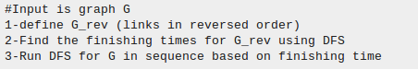
Correctness of kosaraju's SCC:

Claim: the SCC of a directed graph induce an acyclic “meta-graph”

If we think of the “meta nodes” as the scc's, the edges between these meta-nodes are the crossing edges between those scc's.

BFS explores the nodes in layers, so it is capable of finding the shortest path from the source node to a certain node. And for undirected graph, it can also compute all connected components. DFS aggressively goes deep into a branch until it reaches an end then backtracks to shallow nodes. It is good at finding topological ordering of a directed acyclic graph and connected components in directed graphs

